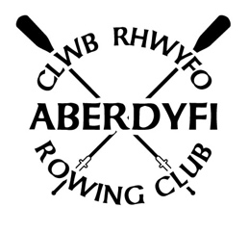

WSRA
Aberdyfi Joint League Race Day
Sunday 11th June 2023

Registration: 10am – 11.15am
Coxes Briefing: 11.30am
First Race: 12.00pm

Race Order: Ladies, Seniors, Juniors/Novices, Mixed
Race Fees: Adults £8, Juniors £2*
(Please note that each club responsibility for providing appropriate certified & DBS Checked safeguarding for their junior members)

Provisional Race Decision: Saturday 10th June 8.00pm
Final Race Decision: Sunday 11th June 7.00am
On Facebook, or Phone: Richard 07748482846

Tea/Coffee & Cakes are available throughout the day.
Food will be served after the final race is complete.
Changing & Shower facilities available (20p Coins required)

Clubs intending to participate please confirm by email to Amanda Martin using amandarwmartin@gmail.com by Sunday 4th June.

Please can all Clubs return any trophies they may have from previous years.

Camping facilities are available at Vaenol Caravan Park 01654 710232 or Woodland Holiday Park 01654 710 471

